Ideation Phase
Empathize & Discover

Date | 26 September 2026
Team ID | 6ab229b877181cf94a22636a
Project Name | AI WeatherWise
Maximum Marks | 4 Marks

Empathy Map Canvas:
An empathy map is a visual tool used to understand the behaviours, thoughts, feelings, and needs of users.
For the AI WeatherWise project, the empathy map helps understand the challenges faced by people when checking weather conditions and planning their daily activities.
It helps identify user needs, problems, and expectations to develop a weather application that provides understandable weather information, AI-generated summaries, personalized recommendations, and convenient access to favorite locations
Reference: https://www.mural.co/templates/empathy-map-canvas
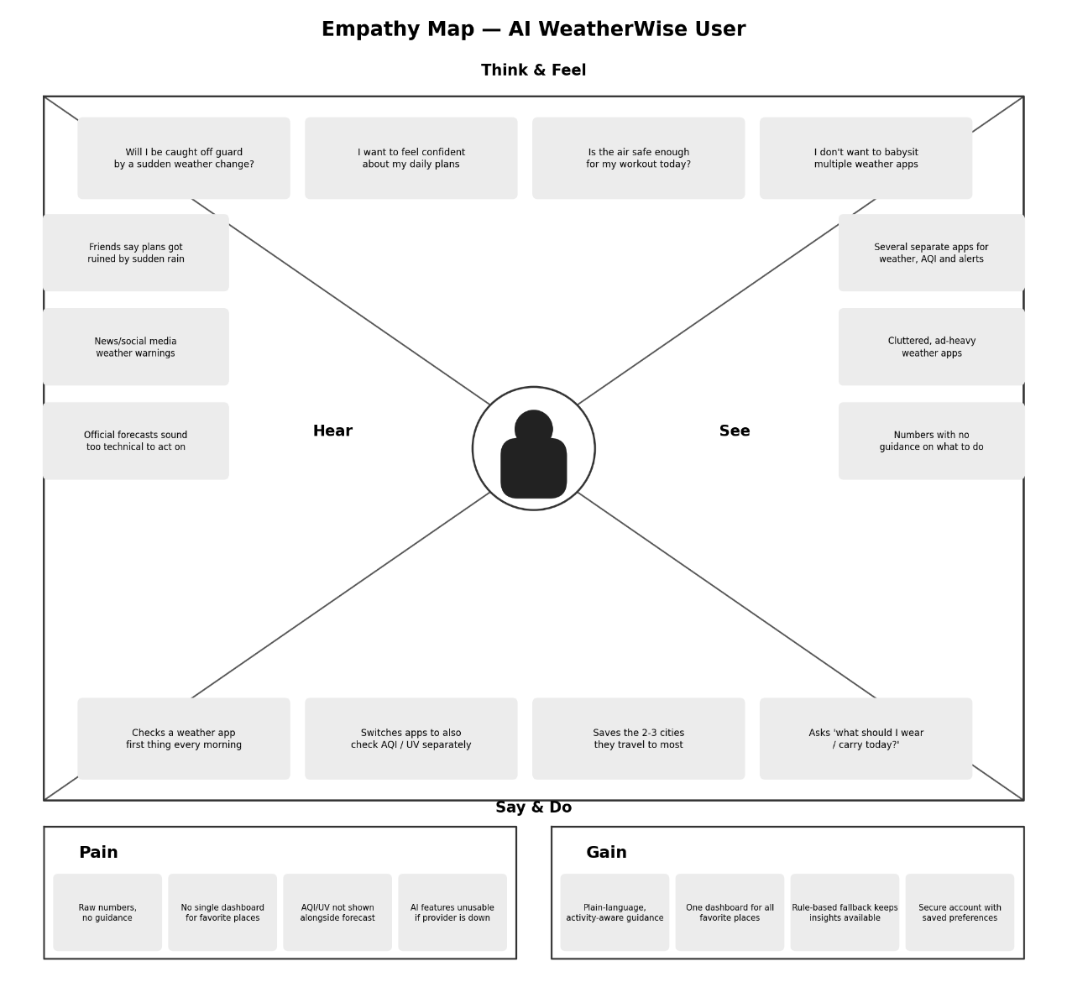
AI WeatherWise — Everyday Weather App User:

